This document will show you two options in adding multiple students to an EMIS Membership.
Step 1: Go to Home » SIS » School » Membership Members
Step 2: Choose the Membership Group and Membership that you would to add students. Once that is chosen you will see any students that are currently in the membership.
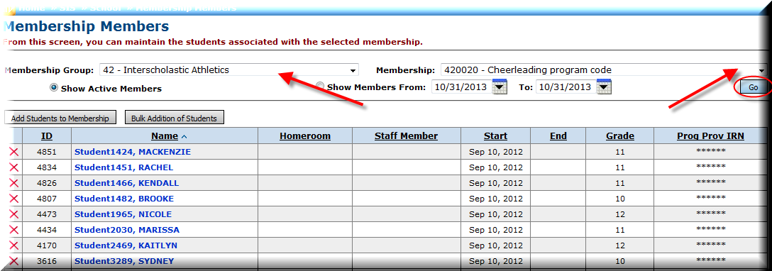

The Show Active Members is chosen by default, but if you want to see any students that may have a start or stop date outside the current date, you would select Show Members From and choose appropriate dates.
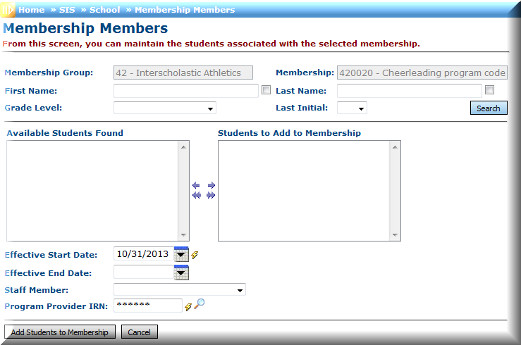
Step 3: Click on Add Students to Membership. You are able to search for students by First Name, Last Name, or Grade Level. Once you have the students selected to add to the membership, enter the Effective Start Date and click Add Students to Membership.

Step 4: If you rather add students by Student ID, you can choose the Bulk Addition of Students. Enter the Student ID numbers in separated by a comma and click View Students once you have the students listed, you will want to click Save.

